**The way to get Google/Gmail/Instagram/Youtube etc. in China**

This MacBook is configured for these services, but you need to know how to enable it working.

Please run the command `ps -ef | grep ssh` in a terminal, to check whether the program `autossh` and `ssh` is running.

If not, then run the command `autossh -M 5122 -CqTnfN -D 127.0.0.1:10080 [unisko@xfoss.com](mailto:unisko@xfoss.com) -p 38460`. This will establish a link to xfoss.com, which located in Japan.

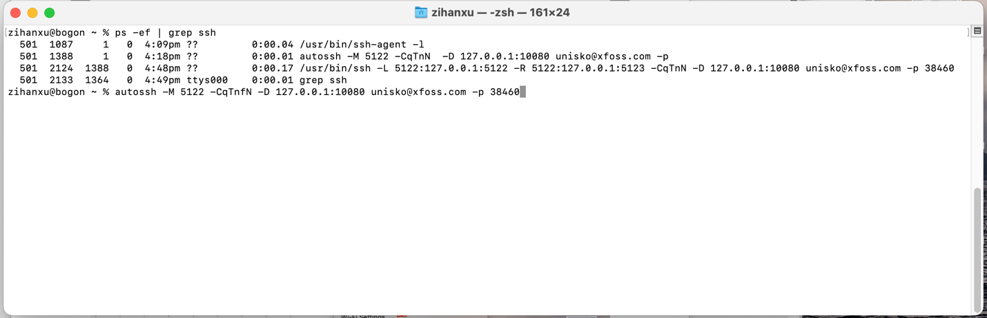

To kill the `autossh` and `ssh` program, you can run `kill -9 pid` command, the pid is the number at second column. In this case, the pid of `autossh` is 1388, and the pid of `ssh` is 2124

When this laptop is connected to a Wi-Fi network (China Unicom network is preferred, as this ISP is best for foreign internet traffic), you need to configure the Wi-Fi, to use the above link.

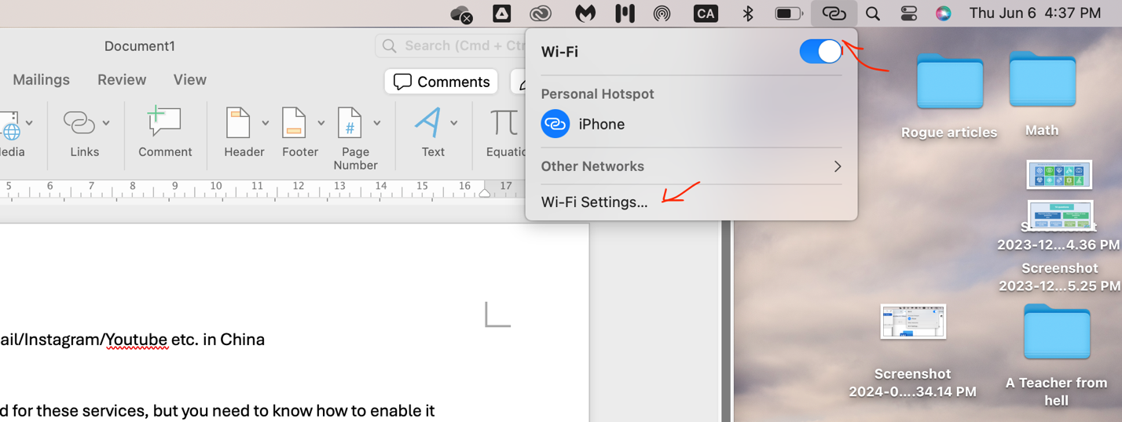

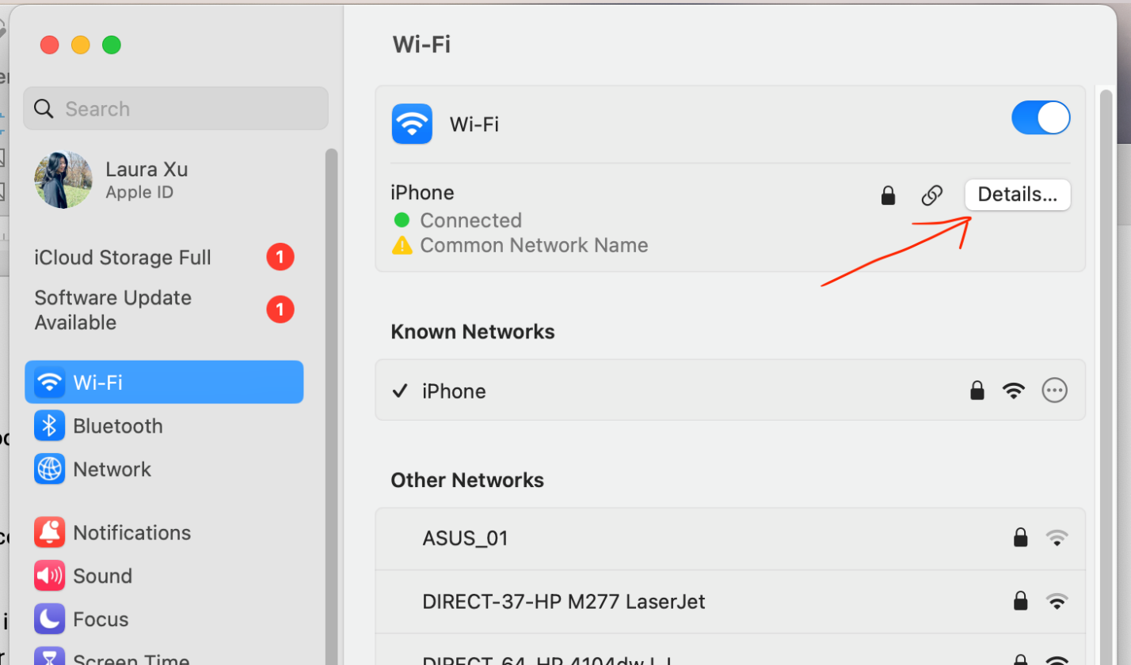

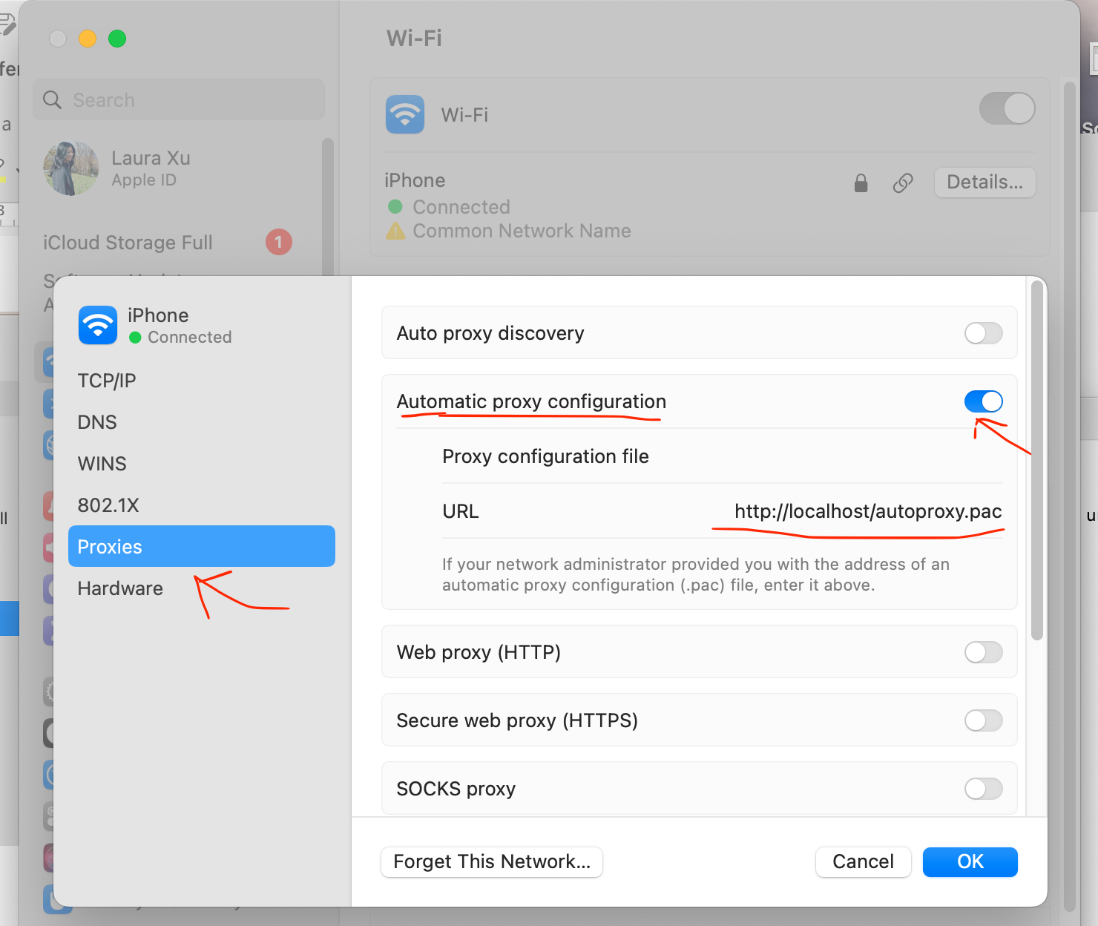

You may need to run the command `sudo apachectl start` (When a password prompt appearing, you should provide your password), to make `http://localhost/autoproxy.pac` available.

Hope you can have all your foreign web services worked!